

**Application Form**

**TD Ignite Grants &**

**Venture Space Internships in Entrepreneurship**

**Steps to apply:**

1. Decide what level of funding suits your project status
2. Create your video
3. Complete the written application – take note of which sections are required for your funding level!
   * TD Ignite Grants = Application Section 1
   * Venture Space Internships = Application Section 1 + 2 + Business Model Canvas
4. Submit your application and link to your video no later January 31!

**Successful applicants will be invited to a Live Pitch in February.**

Check out [Venture Space MTA](https://www.mta.ca/venturespace/)! This is our new portal for all things entrepreneurship – there are a couple of excellent modules on developing ideas and steps to take to get your project off the ground!

**Video Requirements → For ALL Applicants**

The most exciting component of this application will be your video submission. In 3 minutes, you must showcase who you are, what problem you hope to solve and give us a glimpse into the interesting and innovative ways you might be able to find a solution! This could be a product or services that needs to be improved, or a social or cultural enterprise, or it could be a service that is sorely lacking.

Specific points to cover:

* Introduce yourself
* Identify the problem you see in the world
* Why does this problem matter to you?
* Have you identified the solution? Tell us how you intend to tackle this problem!

Three minutes will pass quickly! So, you want to develop a great script that showcases your idea and solution in the best, most clear way. Be creative, engage with your audience. Take us on a tour or let us see into your thought process. You can [find pitching tips here](https://mta.ca/current-students/experiences-and-career/entrepreneurship-mta/think-inc-program/think-inc-module-4).

**Section 1 → For ALL Applicants**

|  |  |
| --- | --- |
| Name of Lead Applicant |  |
| Degree, Major, Minor |  |
| Year of study |  |
| Email |  |
| Cell phone |  |
| Mailing address |  |
| Project Title |  |

**Is this a team project?**

You can have up to 3 team members. Please provide the above information for EACH team member.

**What level of funding are you applying for,**

**Ignite Grant OR Venture Space Internship**

→ ______________________________

Check out the chart below to help choose the funding that best suits your needs:

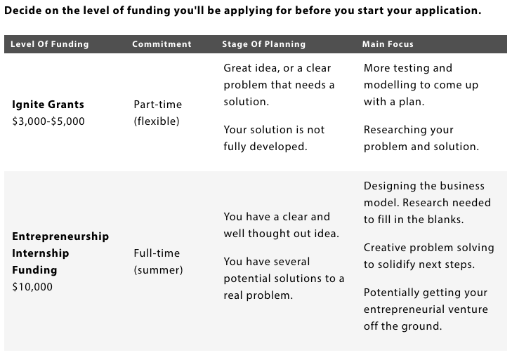

**Your Pitch**

Please recap, in 500 words or less, your video submission. What problem are you trying to solve? What has been your inspiration in tackling this challenge? And finally, what is your vision for this challenge; what does your ultimate solution look like?

**Budget**

What expenses will your project have? In the table below, list your expense by category. Use the justification column to explain why the expense is necessary. You may include salary. Capital expenses (costs to purchase or lease equipment) should be less than 20% of your budget.

|  |  |  |
| --- | --- | --- |
| Account/Category | Expense | Justification |
| Accounting and other professional services |  |  |
| Capital expenses (equipment) |  |  |
| Marketing and promotions |  |  |
| Maintenance |  |  |
| Permits |  |  |
| Office supplies |  |  |
| Rent |  |  |
| Research and development |  |  |
| Salary |  |  |
| Supplies (materials for production) |  |  |
| Telephone |  |  |
| Travel |  |  |
| Web hosting |  |  |
| Other: |  |  |

**Section 2 – For Venture Space Internships in Entrepreneurship →**

The main difference between the Venture Space Internships Funding and the TD Ignite Grant, is that as a Venture Space Intern you will be expected to work full time on your project throughout the summer. You could make great strides in pushing your project forward with the support of the business coach.

In the table below, map out one to three goals you’d like to achieve **each** month of your internship.

|  |  |
| --- | --- |
| **Goals** | |
| May |  |
| June |  |
| July |  |
| Aug |  |

We’re interested in knowing a bit more about your proposed business.

How will you will make money? (Or if you’re starting a social enterprise, you will you achieve financial sustainability?)

1. Please provide a brief description of how your business or social enterprise will work (one to two paragraphs)

**Business Model Canvas**

If you are applying for the $10,000 Venture Space Internship, you **must** include a completed Business Model Canvas.

You can find the forms and information you need to complete a BMC here:

* [Business Model Canvas Template](https://drupal-ha.mta.ca/sites/default/files/2021-04/Lean-Business-Model-Canvas-Template.pdf)
* [Tips for Creating a Business Model Canvas](https://mta.ca/current-students/experiences-and-career/entrepreneurship-mta/think-inc-program/think-inc-module-3)

**Submission Details**

* Deadline to apply is **January 31, 2024.**
* All applications should be sent to [careers@mta.ca](mailto:careers@mta.ca)
* Application Form + [Business Model Canvas](https://drupal-ha.mta.ca/sites/default/files/2021-04/Lean-Business-Model-Canvas-Template.pdf) (if applicable), should be attached as 2 separate documents to your email.
* Please name your files *LastName_FirstInitial Application.doc* and *LastName_FirstInitial BMC.doc*.
* A link to your video should be included in your email (you can share it from your MTA One Drive).

For more details about the application process, the awards and the program itself, please visit the [Entrepreneurship Funding Page](https://mta.ca/current-students/experiences-and-career/entrepreneurship-mta/funding-entrepreneurship).

If you want some support in writing this application, please reach out to [careers@mta.ca](mailto:careers@mta.ca)